**ABC Company Promotion Analysis**

**Presented by**

Chelsey Frizzell

**Introduction**

This report investigates promotional strategies and market characteristics' impact on sales performance. The objective is to assist ABC Company in discovering what channels respond best to which promotions, aiding in making informed decisions about which promotions to use to increase sales performance across regions.

**Key Insights**

* Market ID and Location ID are all associated with a particular market size, thus it is unnecessary to evaluate these factors independently, as they inherently reflect the size of the market.

**Analysis**

**Sales Performance by Promotional Type**

* Figure 1 displays sales performance of all three promotions:
  + Promotion 1: 34.11%
  + Promotion 2: 30.37%
  + Promotion 3: 35.52%

Figure 1 depicts that all three promotions are effective, though Promotion 3 has slightly higher effectiveness.

**Figure 1**

**Promotions by Market Size**

* In Figure 2, you will see a breakdown of how the promotional strategies performed in small, medium and large markets. Medium market sizes led in for all 3 promotion types accounting for 48% of sales performance. However, promotion 3 performed the best in medium-sized markets, contributing 18% of total sales.

Figure 2

* **Promotions by store age**
  + Figure 3 illustrates promotions by store age. Year 1 leads in total sales performances accounting for 15.95% of total sales. Promotion 2 was the most effective with 6.10% of the sales. This suggests that consumers respond better to grand openings.

Figure 3

* **Year 1 impact on promotions**
  + Figure 4 displays the total sales percentage of each promotion in year 1 by market size. Large markets dominated 50.89% of sales, showing the best responses to promotion 1 and 3. While promotion 2 responded best to medium and small markets.

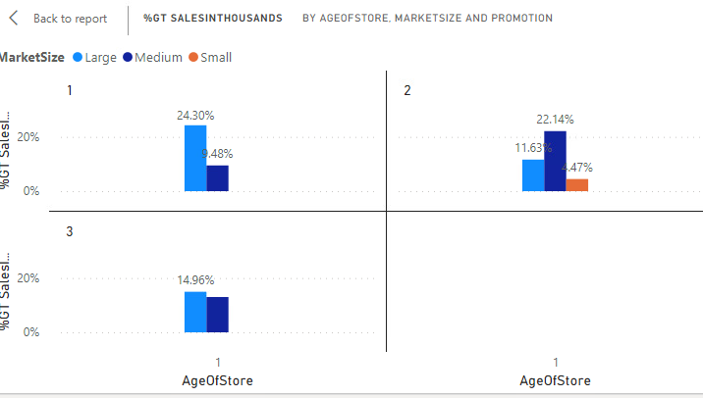

Figure 4

**Conclusion**

The data determined that promotions perform differently according to factors such as market size and store age. Recommendations on how to best direct these efforts for expansion include:

* **Strategizing promotions by market size**
  + Tailor the focus of Promotion 1 and 3 to large size markets.
    - Utilize influencer partnerships, Ads (on large platforms like YouTube and Google), and email marketing.
  + Target Promotion 2 in small and medium sized markets.
    - Utilize local newsletters, regional TV and radio advertisements and local billboards.

By targeting market size especially in the first year, funding for advertisement can be customized to enhance the opportunities to maximize profit.

**Security Plan**

Carrying out an effective Information Technology (IT) security plan in support of promotional campaigns would involve addressing a few key areas. Security measures will be needed to protect customer data and ensure the integrity of the company's promotional activities. Here is an IT security plan:

* Any collection of data associated with promotions will require compliance with data privacy regulations.
  + **Industry Regulations**: Maintain compliance with industry-specific regulations, such as General Data Protection Regulation (GDPR), California Consumer Privacy Act (CCPA), and Payment Card Industry Data Security Standard (PCI-DSS) for payment processing (Bansal, 2024).
* Back plans need to be in place in case data is compromised.
  + **Disaster Recovery**: Regularly test the disaster recovery plan to ensure systems can be restored quickly in case of a breach or failure (Velimirovic, 2022).

References:

Bansal, A. (2024, May 16). *GDPR vs. HIPAA vs. CCPA vs. PCI: Compliance Differences*. CloudDefense.AI. <https://www.clouddefense.ai/gdpr-vs-hipaa-vs-ccpa-vs-pci/>

Velimirovic, A. (2022, March 24). *Backup vs Disaster Recovery: What’s the Difference*. PhoenixNAP Blog. <https://phoenixnap.com/blog/backup-vs-disaster-recovery>